Game of Towers

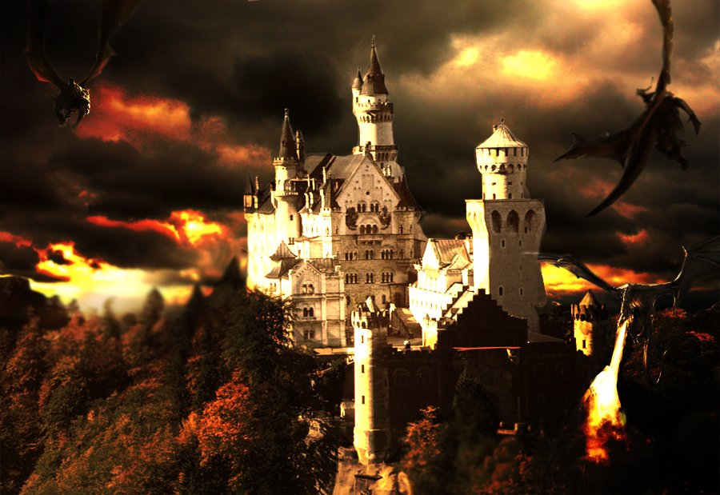

**Game Design Document**

**Version 0.1**

23 April 2014

Table of Contents

[2 Design History 5](#_Toc386021306)

[3 Team Personnel 6](#_Toc386021307)

[4 Section I - Game Overview 7](#_Toc386021308)

[4.1 Game Concept 7](#_Toc386021309)

[4.2 Genre 7](#_Toc386021310)

[4.3 Target Audience 7](#_Toc386021311)

[4.4 Game Flow Summary 7](#_Toc386021312)

[4.5 Look and Feel 7](#_Toc386021313)

[4.6 Project scope 8](#_Toc386021314)

[4.6.1 Environments 8](#_Toc386021315)

[4.6.2 Levels 8](#_Toc386021316)

[4.6.3 Characters 8](#_Toc386021317)

[4.6.4 Projectiles 10](#_Toc386021318)

[4.6.5 Power-Ups 11](#_Toc386021319)

[5 Section II - Gameplay and Mechanics 12](#_Toc386021320)

[5.1 Gameplay 12](#_Toc386021321)

[5.1.1 Mission/challenge Structure 12](#_Toc386021322)

[5.1.2 Objectives 12](#_Toc386021323)

[6 Mechanics 12](#_Toc386021324)

[6.1 Movement 12](#_Toc386021325)

[6.1.1 General Movement 12](#_Toc386021326)

[6.2 Win Conditions 12](#_Toc386021327)

[6.3 Loss Condition 13](#_Toc386021328)

[7 Screen Flow 13](#_Toc386021329)

[7.1.1 Screen Flow Chart 13](#_Toc386021330)

[7.1.2 Screen Descriptions 14](#_Toc386021331)

[8 Section III – Interface 14](#_Toc386021332)

[8.1 Visual System 14](#_Toc386021333)

[8.1.1 HUD 14](#_Toc386021334)

[8.1.2 Rendering System 15](#_Toc386021335)

[8.2 Control System 15](#_Toc386021336)

[8.2.1 Mouse Controls 15](#_Toc386021337)

[8.3 Menu and General Game Usage 15](#_Toc386021338)

[8.3.1 Splash Screen 15](#_Toc386021339)

[8.3.2 Title Screen 15](#_Toc386021340)

[8.3.3 Start Game Screen 15](#_Toc386021341)

[8.3.4 Option Screen 16](#_Toc386021342)

[8.3.5 Pause Menu 16](#_Toc386021343)

[8.3.6 Loss Screen 17](#_Toc386021344)

[8.3.7 Credits 17](#_Toc386021345)

# Design History

|  |  |  |
| --- | --- | --- |
| **Changes** | **Contributors** | **Date** |
| Original Draft | Neilson | 17 April, 2014 |
| Title, Section 1 – 4.6.3 | Neilson, Jonathon, Brandon | 18 April, 2014 |
| Section 4.6.3.1 – 4.6.3.2 | Neilson | 19 April, 2014 |
| Section 5 | Neilson | 22 April, 2014 |
| Section 4.6.4, 4.6.5, 6, 7.1 | Brandon | 22 April, 2014 |
|  |  |  |
|  |  |  |

# Team Personnel

|  |  |
| --- | --- |
| Neilson Leslie | Programmer |
| Brandon Coulthard | Programmer |
| Jonathon MacLachlan | Programmer |

# Section I - Game Overview

## Game Concept

The game “Game of Towers” is a simple tower defense game. The player will try to eliminate waves of “invaders” and stop them from destroying his castle/tower.

Each level has a single waves of enemies with each level introducing a new enemy or combination of previously encountered enemies. As the player is able to accomplish the task of defeating each wave, the next wave becomes more difficult. Instead of being stationary objects, various enemies have special attributes about them. Some enemies move faster than others, some requires to be hit by the player’s more than once before that enemy is defeated. The projectiles from the enemies are also destroyable by shooting before they hit the castle/tower

## Genre

The game genre is an action game.

## Target Audience

The audience that this game will appeal to will be all ages and test the player visual and reflexes while employing a fun factor and imaginative immersion.

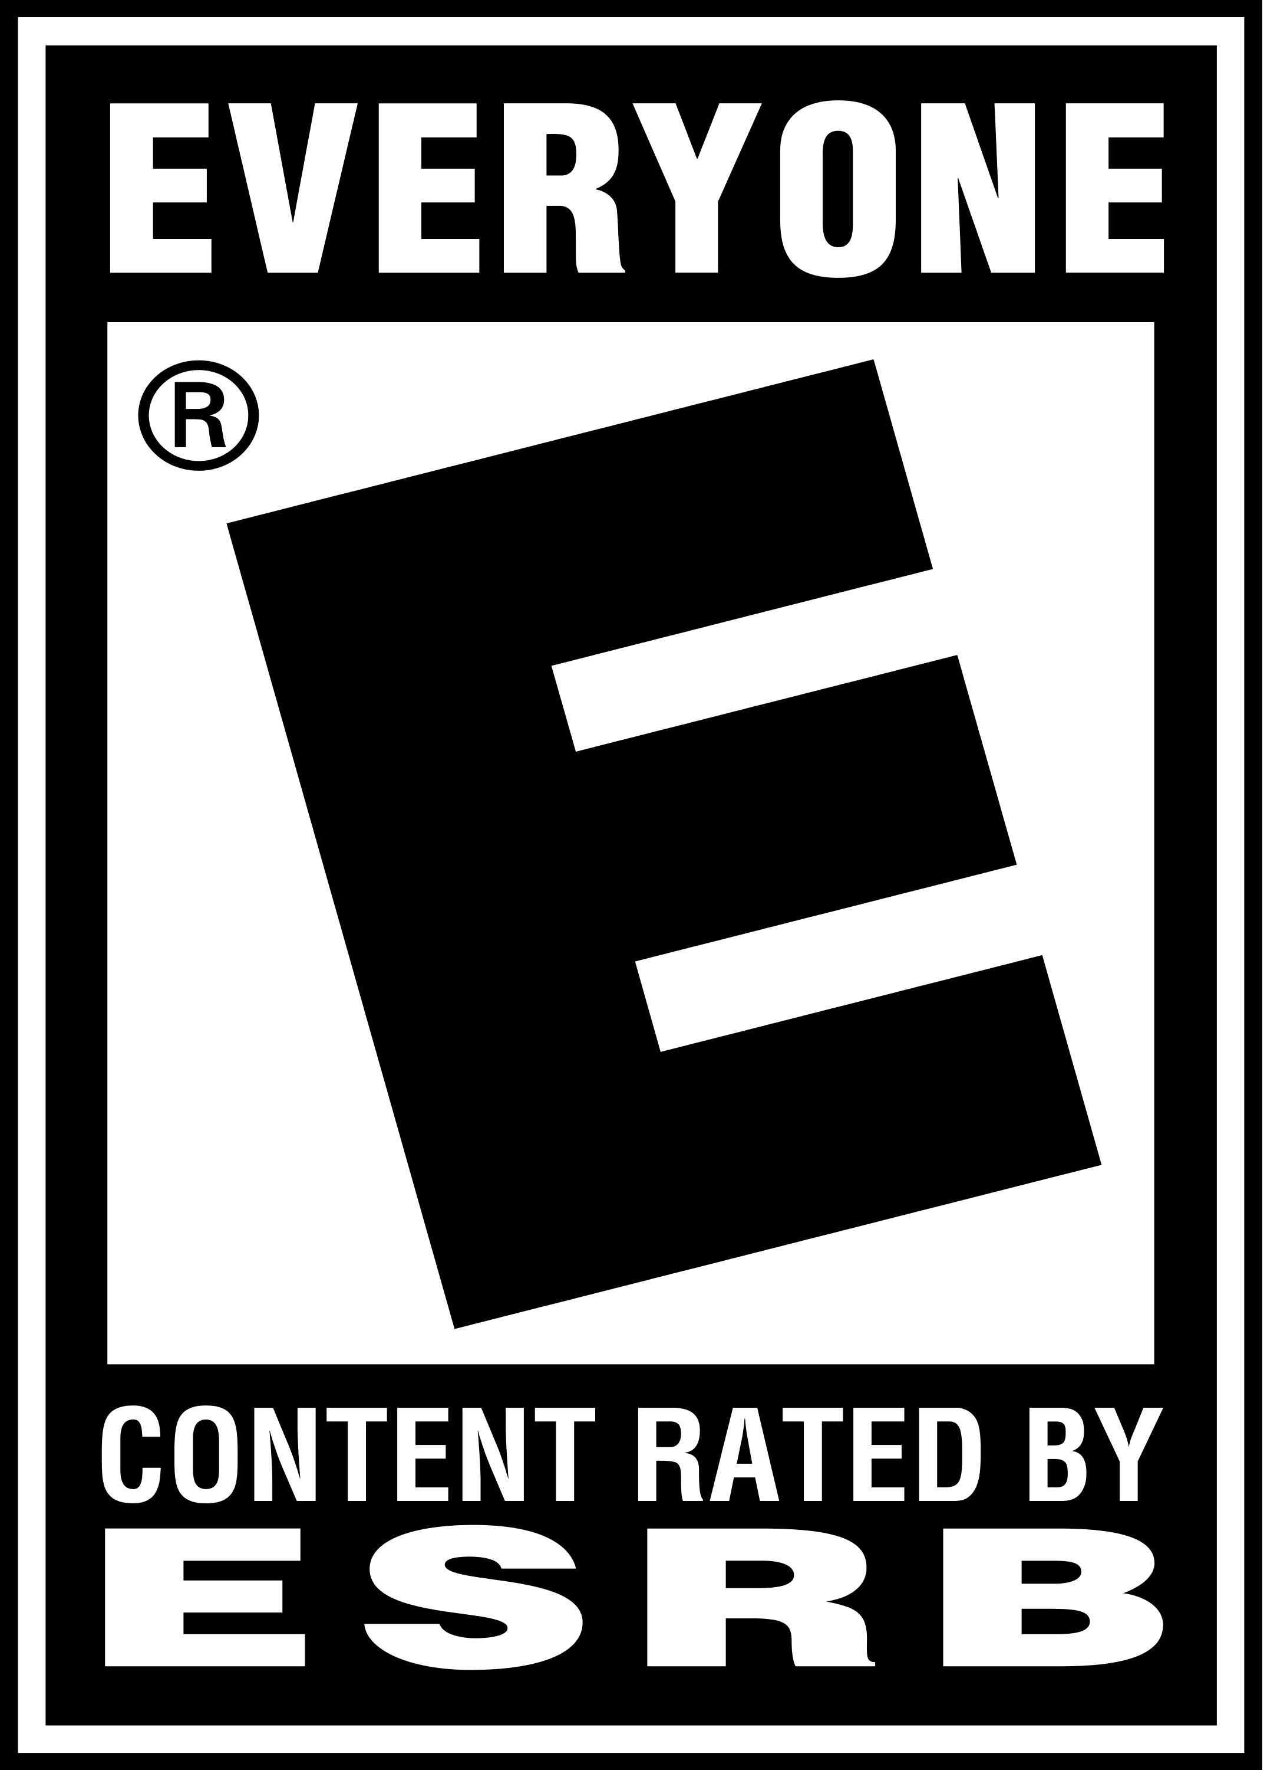

## Game Flow Summary

The player progress through each level. To progress to the next level, the player must destroy all enemies for that level. There is no limit on levels, simply play until you get a game over.

## Look and Feel

The plot is that the player is a Master Wizard and the player sole goal is to defend the castle/tower from an onslaught of enemy invaders. As the user/player you have to guide the direction of the Wizard’s attack to stop the invader’s enemy fire as well as eliminating the invaders themselves. This is a battle for the survival of your kingdom and you are their last hope. Prove your mettle and show those invaders that the Kingdom of Fiore is strong and will not be defeated. Beat the mission and come home a hero!!

## Project scope

### Environments

The environment will never change. The terrain will be constant and the position of the castle/tower will always be in the center.

#### Location – The Kingdom of Fiore

The Kingdom of Fiore will be what the player is defending. The Castle/Tower has a total of 50 hit points in total and as enemy projectiles hit the castle, health depleted accord to the damage deliver by the respective projectile. If Castle’s hit points reach zero the game is over.

### Levels

There is no limit to the levels within the game. The game is a survival title where the player keeps completing generated enemy levels till castle is destroyed. For the first few levels, the game start slowly with a small number of enemies to clear the level as an interactive learning curve and then increases the variety of enemies appearing. As the levels get higher, the number of enemies needed to complete each level will increase. At these higher levels, there will be a cap on how many will show in the game screen at a time and until the player reduces, none will be spawn till enemies are eliminated.

### Characters

The characters within the game is the avatar representing the player and the various enemy types. The player is represented by a wizard-type sprite standing in the center tower of the castle. The enemies vary in type and colour to quickly identify their differences in abilities and attributes. Each level introduces a new enemy to utilize in combination with previously encountered enemies.

#### Wizard

The Wizard King, “Joffrey” will be the player controlled avatar used to defend the castle and stop the invaders. The wizard will be restricted to the Y axis and X axis. Motion is positive and negative rotation movement about the Y axis.

The Wizard: 

#### Enemies

We have designed three kinds of enemies that we have designed for this game. There are three types of enemies; the airship, the siege weapon and the dragon-type beast.

Each of the types of enemies have three levels with each level stronger than its predecessor.

##### The Airship:

Lvl 1: Lvl 2:



Airship #1:

Attack every 3 seconds. Drop a single bomb vertically. A single bomb deals a damage of 5 points. Move at a constant speed across the screen. This airship has no armour and a health total of 12 points.

Airship #2:

Attack every 3 seconds. Drop two bombs vertically. A single bomb deals a damage of 5 points. Move at a constant speed across the screen. This version of the airship has an armour of 4 points and a health total of 20 points.

##### Siege Weapon:

Lvl 1:  Lvl 2:



Siege Weapon #1:

Rolls on to the hillside to attack. The siege weapon attacks with a single bolt every 5 seconds. The damage received from a single bolt is 4 points. This siege weapon has no armour and a health total of 10 points.

Siege Weapon #2:

Rolls on to the hillside to attack. The siege weapon attacks with two bolts every 5 seconds. The damage received from a single bolt is 4 points. This siege weapon has no armour and a health total of 15 points.

##### Dragon-type beast:

Lvl 1: Lvl 2:

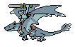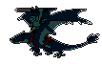

Drake:

The drake flies in from the side and can attack every 2 seconds. A single fireball is fired diagonally. The total damage that can be dealt is 10 points. A player’s counterattack can reduce the amount of damage until all is blocked and stop the attack. The drake has an armour defense of 5 points and a total health of 15 points.

Wyvern:

The wyvern flies in from the side and can attack every 2 seconds. A single fireball is fired diagonally. The total damage that can be dealt is 10 points. A player’s counterattack can reduce the amount of damage until all is blocked and stop the attack. The wyvern has an armour defense of 5 points and a total health of 15 points.

### Projectiles

There are four types of projectiles in Game of Towers, three of which are enemy attacks and one is the player’s defensive attack.

**Magic Orb Attack:** The wizard shoots this projectile at the enemies in order to defend the castle.



**Bombs:** Ships drop bombs vertically down onto the castle which explode upon impact.



**Siege Weapon Bolts:** The siege weapons fire bolts at rapid pace at the castle. They do less damage than bombs or fireballs but fire at a much quicker pace.



**Fireballs:** Dragons shoot fireballs that deal a high amount of damage that take multiple hits to destroy.



### Power-Ups

Ships can drop a power up at random points when they are destroyed which give the player either a damage increaser, or a health restore power up. Once a power up is collected it is automatically used.

#### Damage Increase:

#### Increase player damage for 15 seconds by 5 points

Damage Power-Up: 

#### Health Restore:

#### Will increase castle health by 10 points but won’t increase it beyond the castle health capacity.

Health Power-Up: 

# Section II - Gameplay and Mechanics

## Gameplay

### Mission/challenge Structure

The game will take place at Castle Heimdell in the Kingdom of Fiore. The invading forces have made it within the kingdom’s borders and lands and are ready to lay siege to the Castle. As the wizard King, Joffrey, you will fight from the battlement of your tallest tower and defend the Castle from the onslaught. The challenge is to keep the health of your Castle above zero at all times. The health from the previous level carries forward into the next level.

### Objectives

The objectives of the game are:

1. Successfully defend the Castle from each wave of invaders.
2. Armed with a powerful spells, the wizard Joffrey defend and fight off the attacks by skillfully destroy the projectiles as well as the enemies.
3. Destroy all enemies for to complete each level and progress to the next level.
4. Don’t let the Castle’s hit points reach zero.

# Mechanics

## Movement

### General Movement

The general movement is the position the wizard is looking at but neither his X value or Y value ever change. You use the mouse to point where the wizard is looking at and his sprite matches the direction the mouse is at.

## Win Conditions

The player tries to get the best high score possible to be recognized on the leader board. The leader board records the total time the player survived the game and is placed on the leader board rankings. Complete the game as fast as possible.

## Loss Condition

The castle’s health reaches 0 the game has ended and the player has the option to replay the game or quit. A game over message will be displayed.

# Screen Flow

### Screen Flow ChartC:\Users\Lord_Oni\AppData\Local\Microsoft\Windows\INetCache\Content.Word\Game of Towers Flowchart.png

### Screen Descriptions

1. Title Screen shows the title of the game and acknowledgement of the developer and publisher team
2. The Main Menu screen gives the user the option to make an input to navigate to other screens; Start Game, Options or Quit
3. The Start Game will start the game
4. The Option Screen will open to another screen where the player can adjust the sound and music levels
5. The Credits screen lists and acknowledge those who contributed or whose work may be used to make this game.
6. The Quit screen exits the game.

# Section III – Interface

## Visual System

### HUD

The screen will show what wave the player is on at the top left of the screen, the score which is the total time the wave took to complete and that will be used to create a score multiplier which will be placed underneath the wave counter, a power up meter that will hold the attack power up if the user has one activated at the top right of the screen, underneath the power up meter an enemy’s remaining counter, and the castle’s health will be recorded on the castle itself.

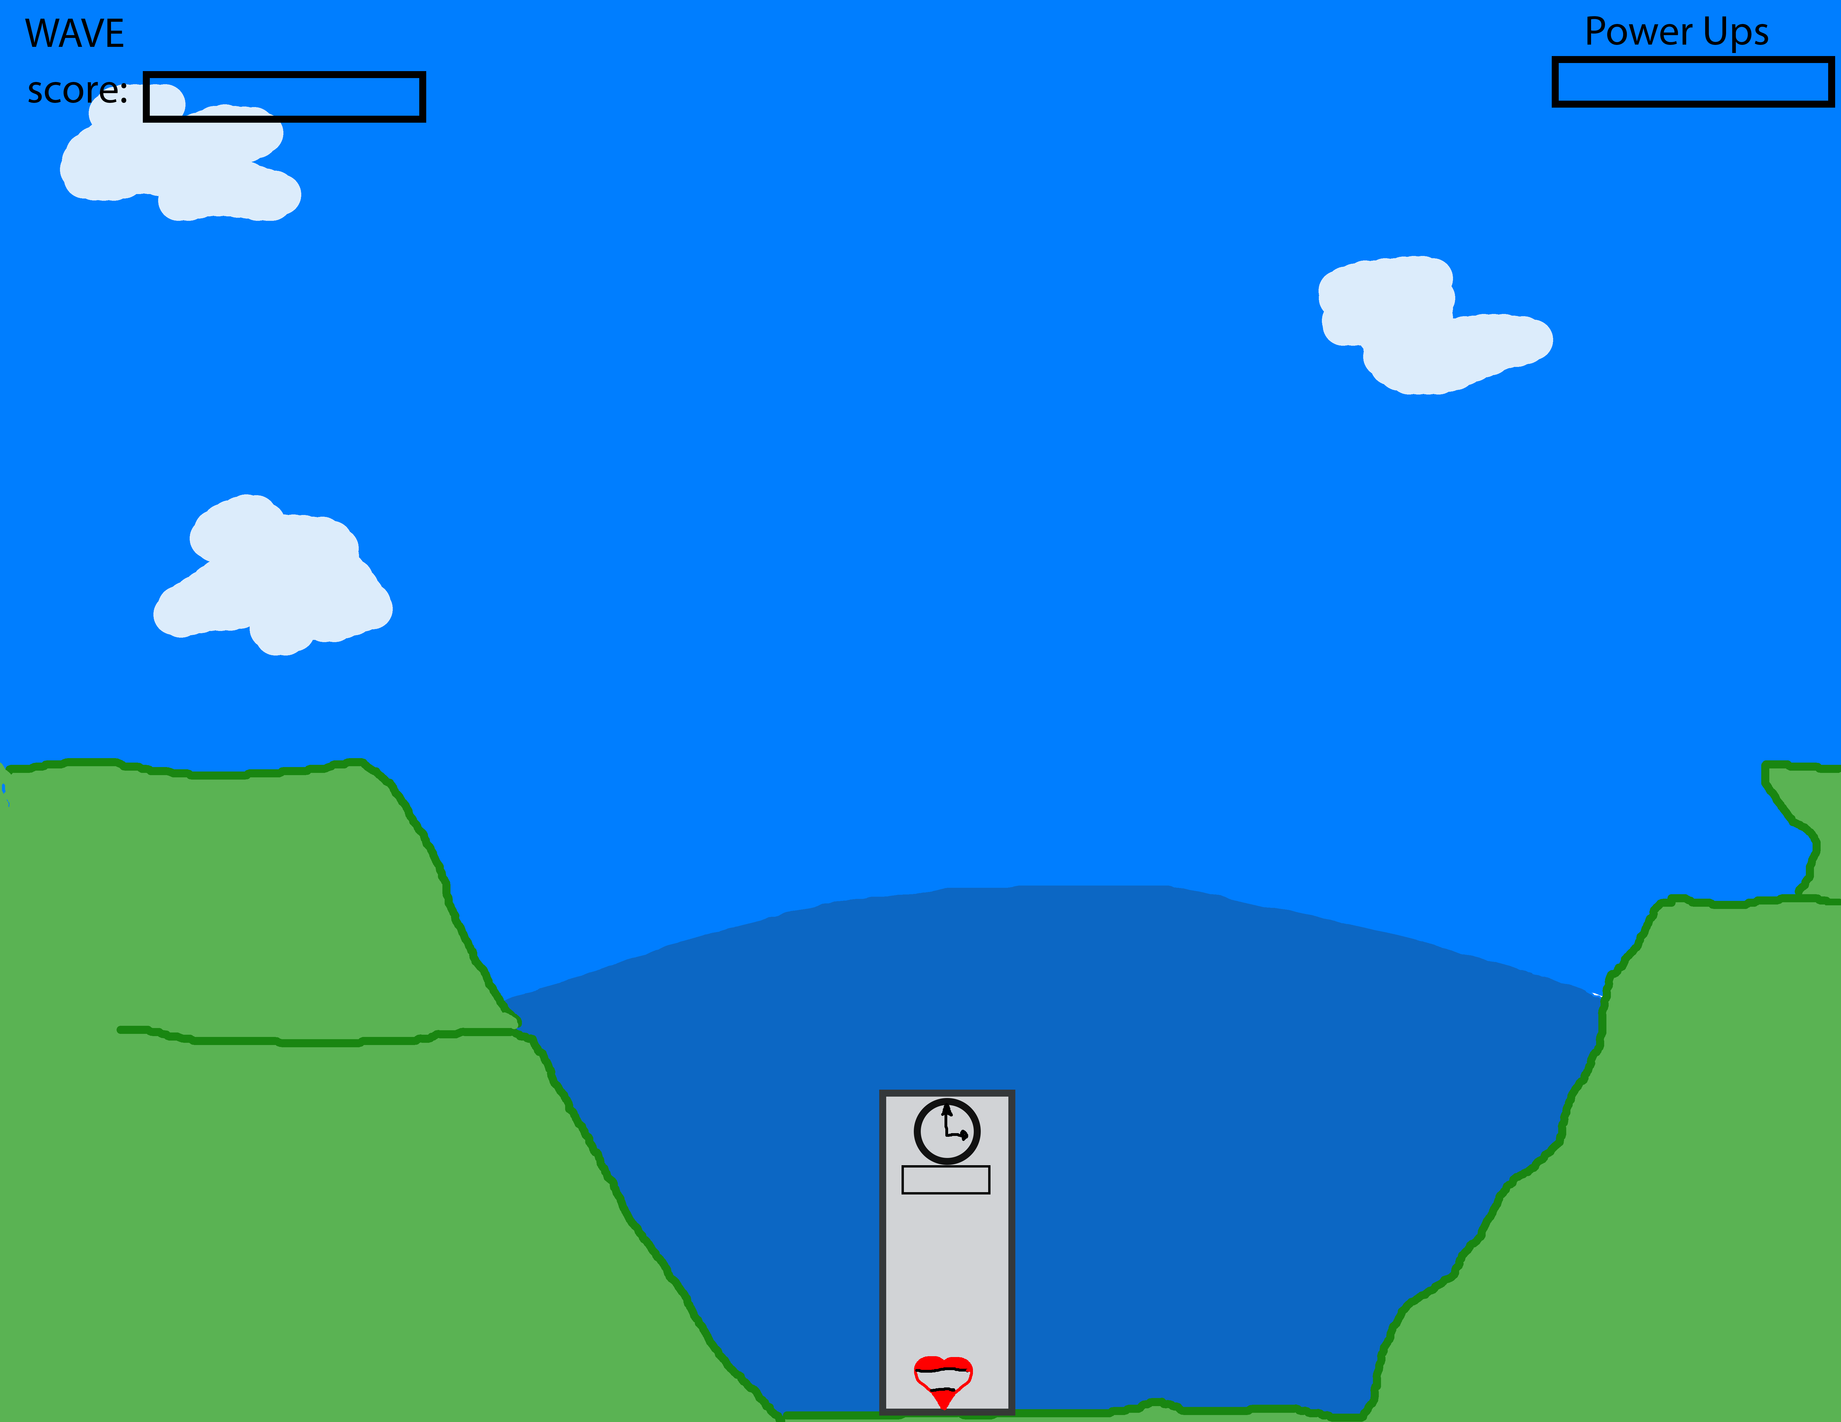

### Rendering System

The rendering system is HTML5 Using Canvas.

## Control System

### Mouse Controls

The mouse controls the direction and angle the wizard will target the enemy at and the left button fires the wizards spell. No other controls are implemented.

## Menu and General Game Usage

### Splash Screen

The First screen upon start-up will have the title and a picture related to the game. Will last for 5 seconds then fade to the main menu.

### Title Screen

The main menu for the game has three options; Start Game, Options and Quit Game. Start Game would start the game while Quit Game will exit the program.

### Start Game Screen

This is the start of the game.

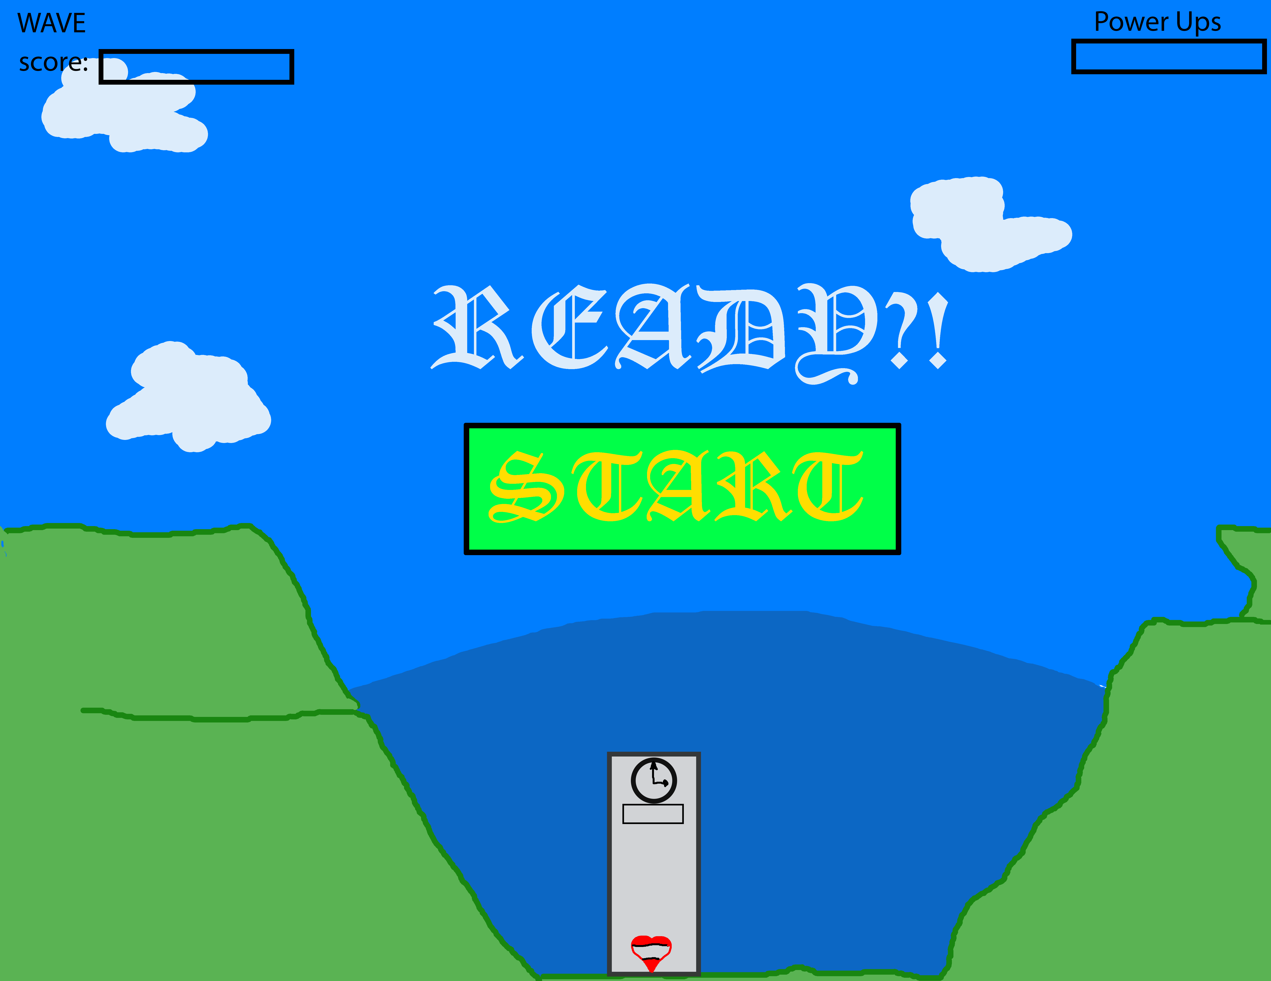

### Option Screen

The option menu will allow you to change sounds and music volume or disabling sound and music altogether.

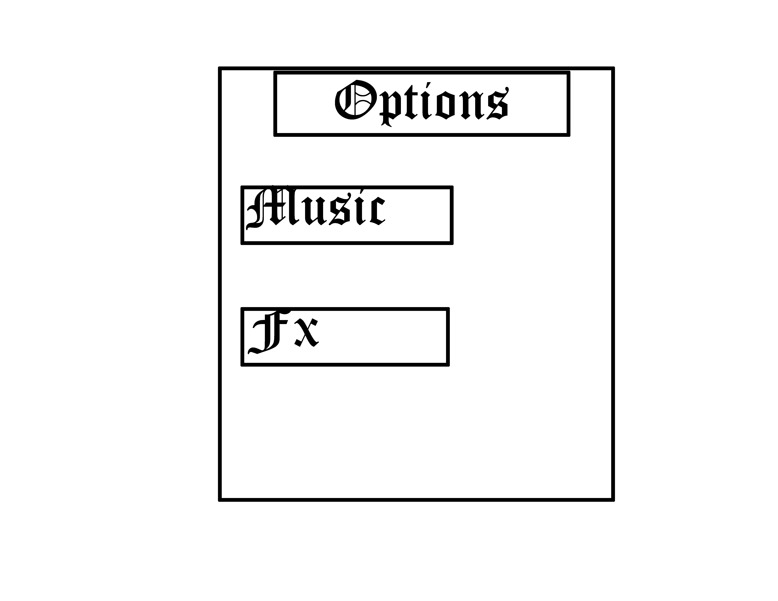

### Pause Menu

This screen will only be displayed during gameplay and will consist of a Resume or Quit button.

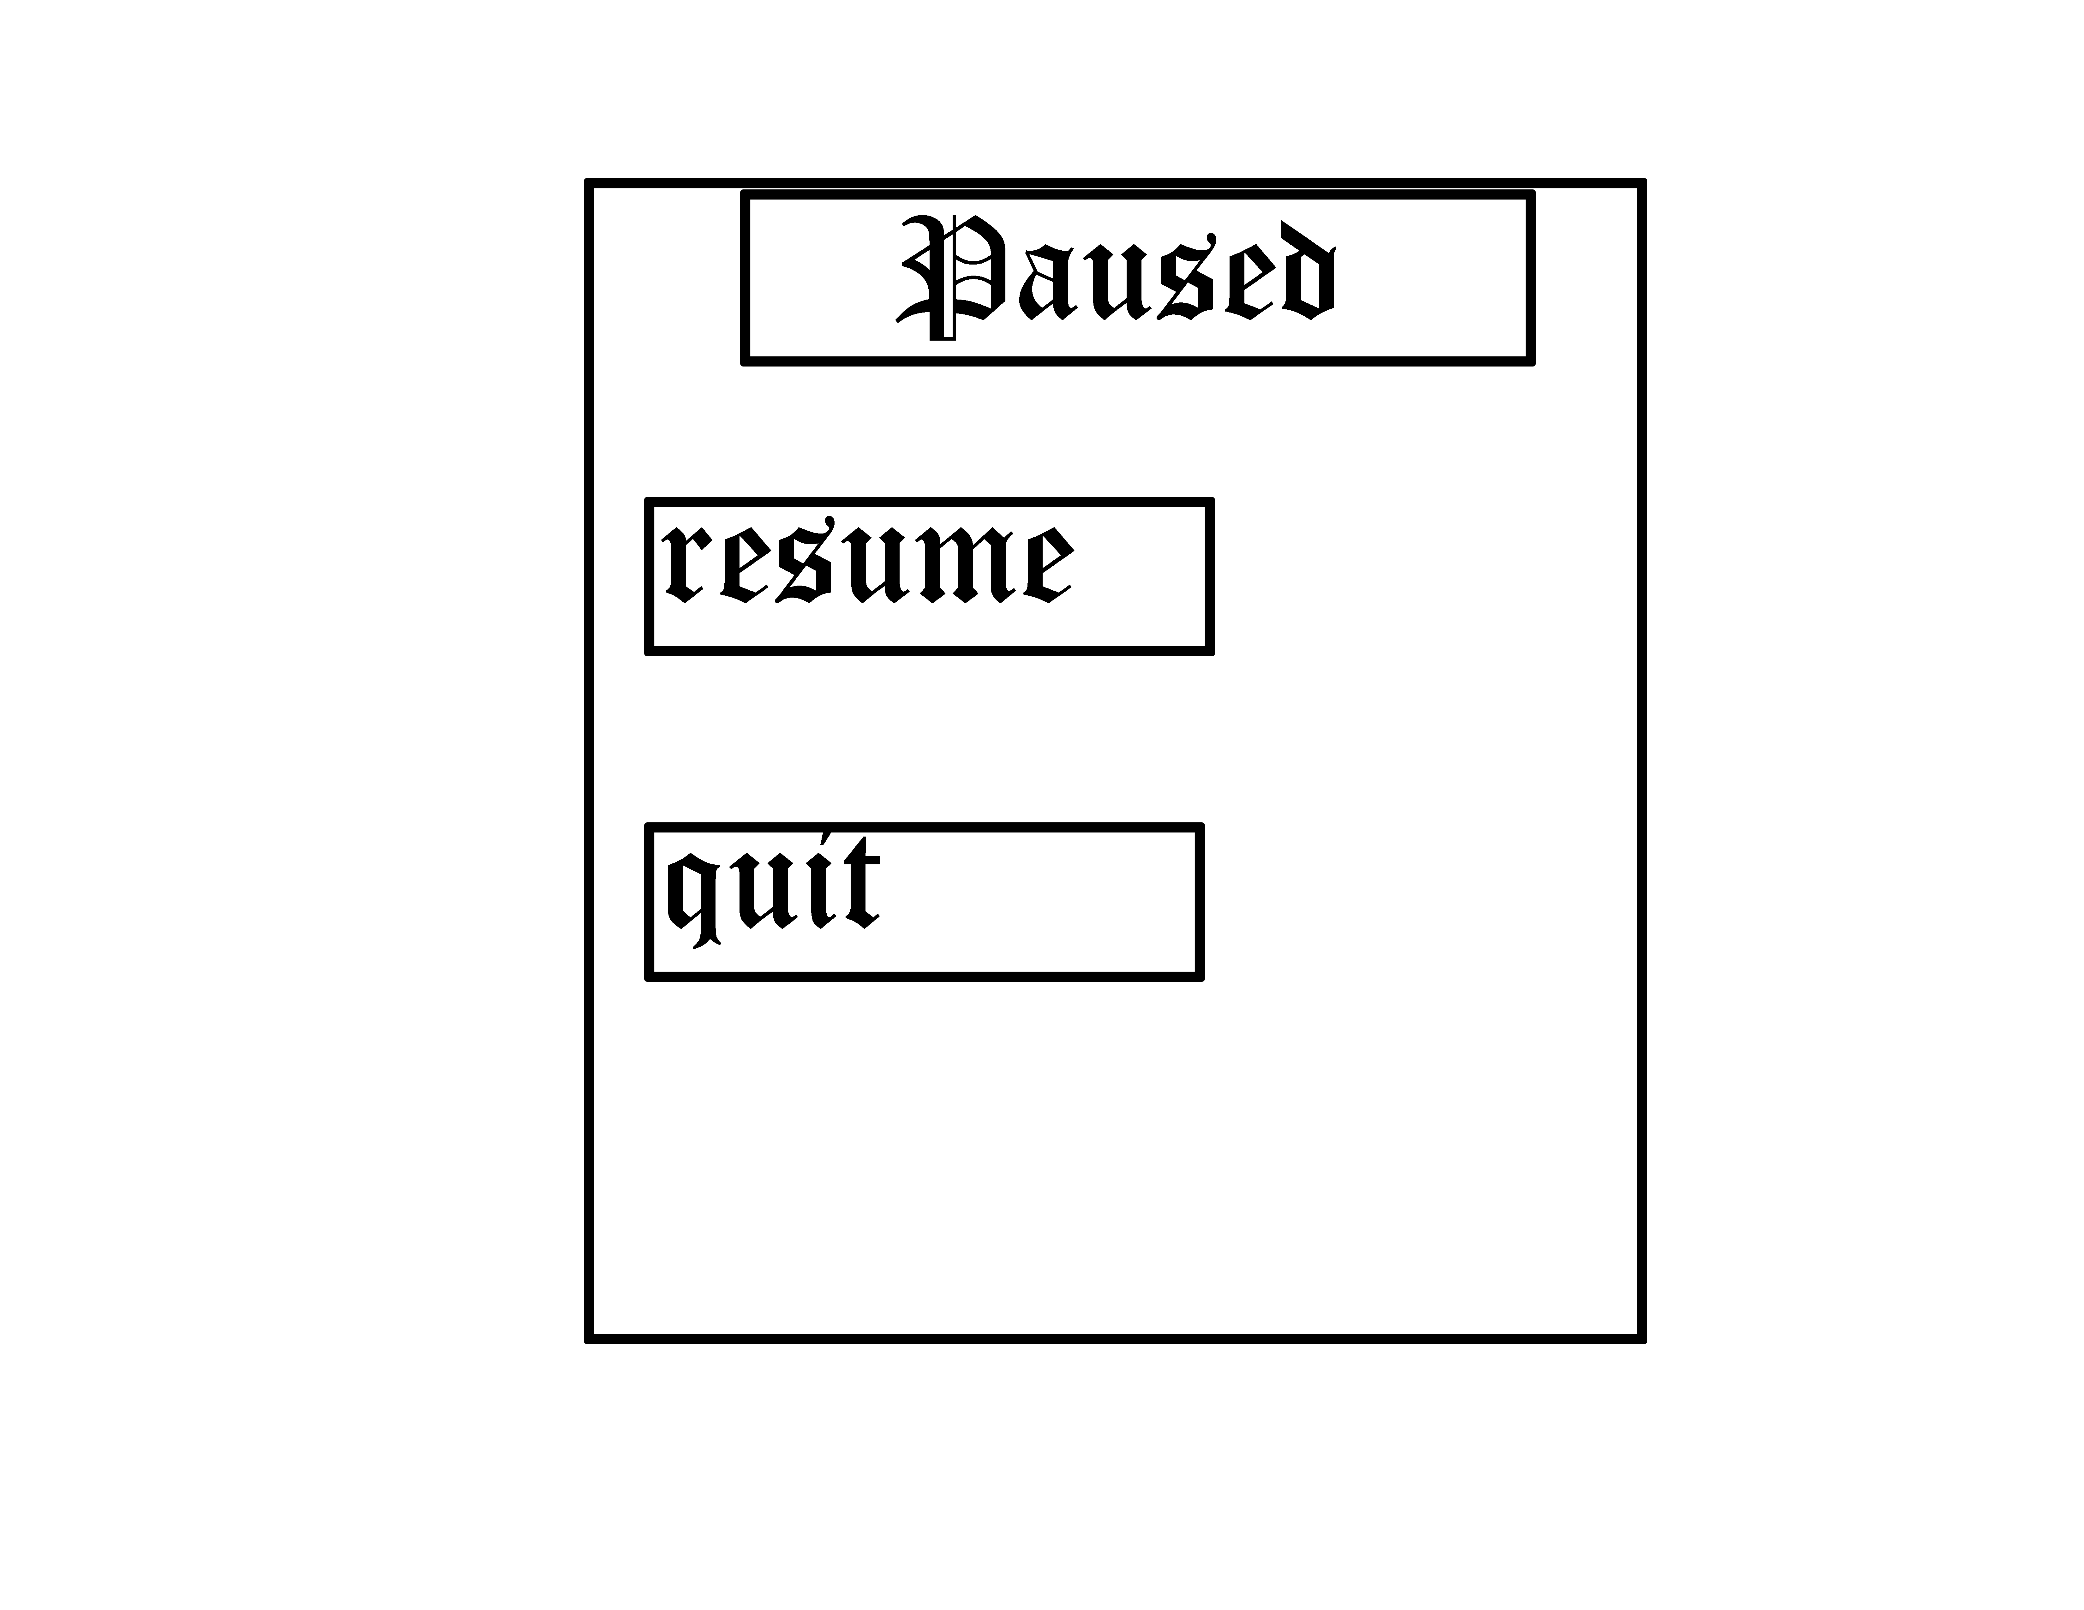

### Loss Screen

If at all through the game any loss condition is achieved a screen will pop up with two buttons: Retry or Quit. Retry will start that level from the first wave.

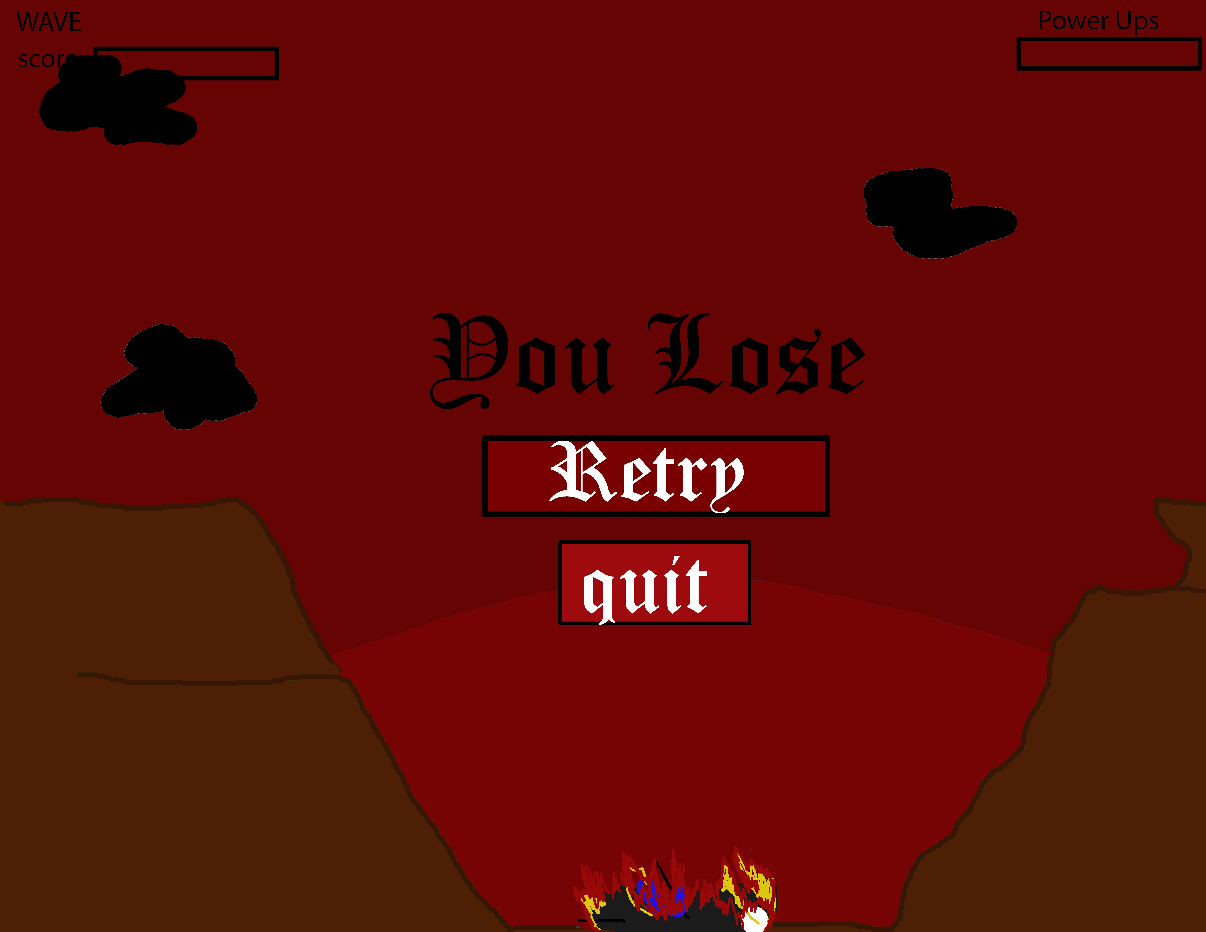

### Credits

The credits screen can be view from the title screen and then go back once viewed.